Instruct1

Each problem in this test has five sets of letters with four letters in each set.

Four of the sets of letters are alike in some way.

You are to find the rule that makes these four sets alike.

The fifth letter set is different from them and will not fit this rule.

You will have to click on this fifth letter set to indicate your answer.

Please click the mouse to continue.

Instruct2

The rules will NOT be based on the sounds of sets of letters, the shapes of letters, or whether letter combinations form words or parts of words.

The first practice example is on the next slide.

Try to find the rule that applies to four of the letter sets, then click on the letter set that does not follow the rule.

Please click the mouse to continue to the first practice example.

Example1

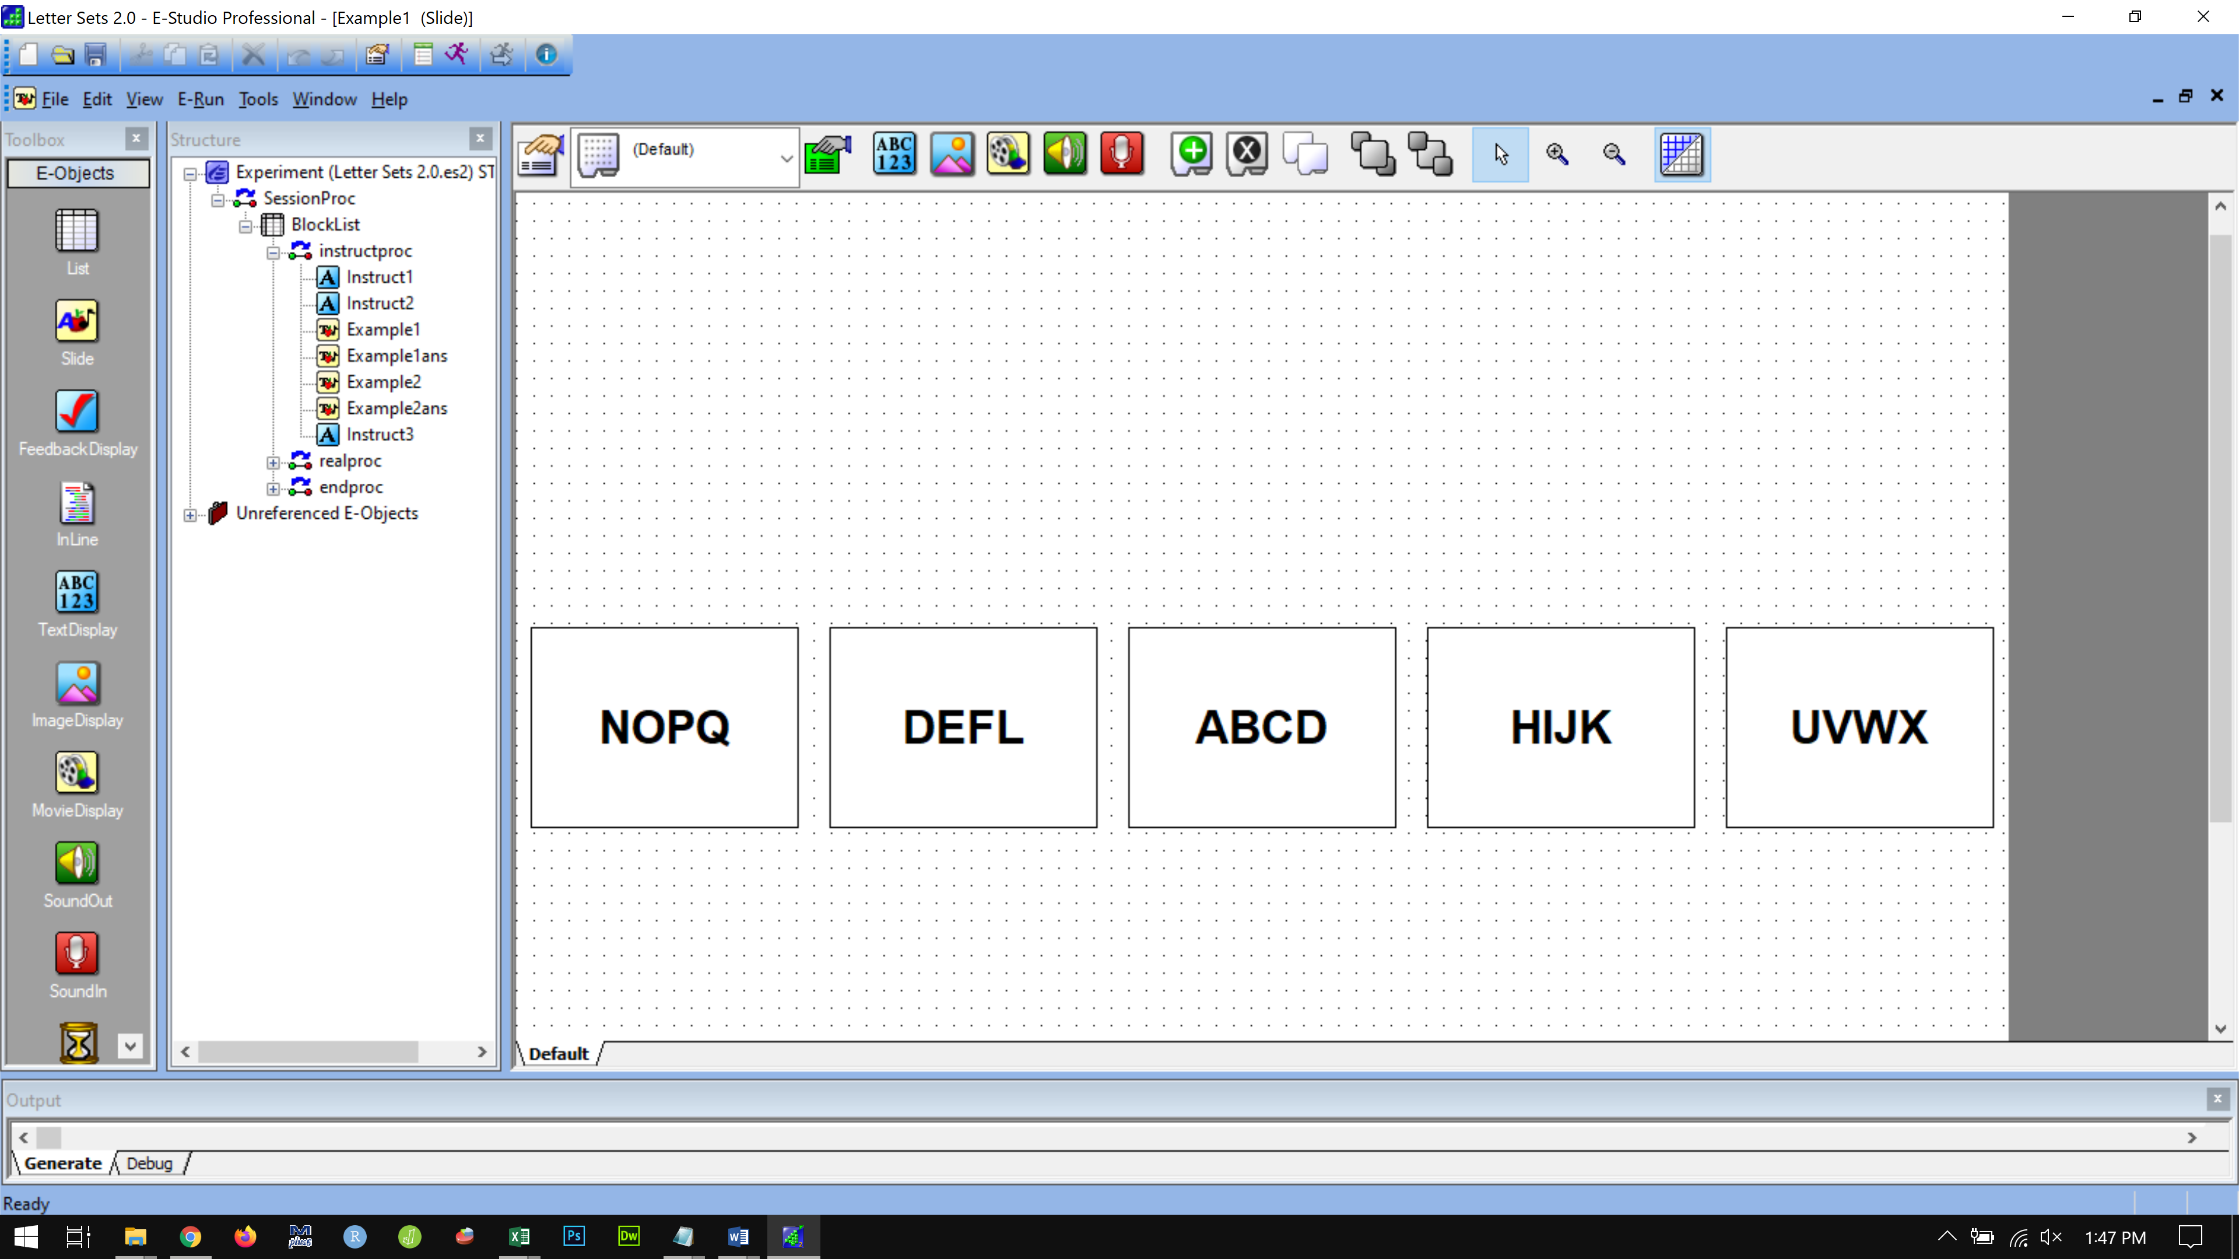

Example1 ans

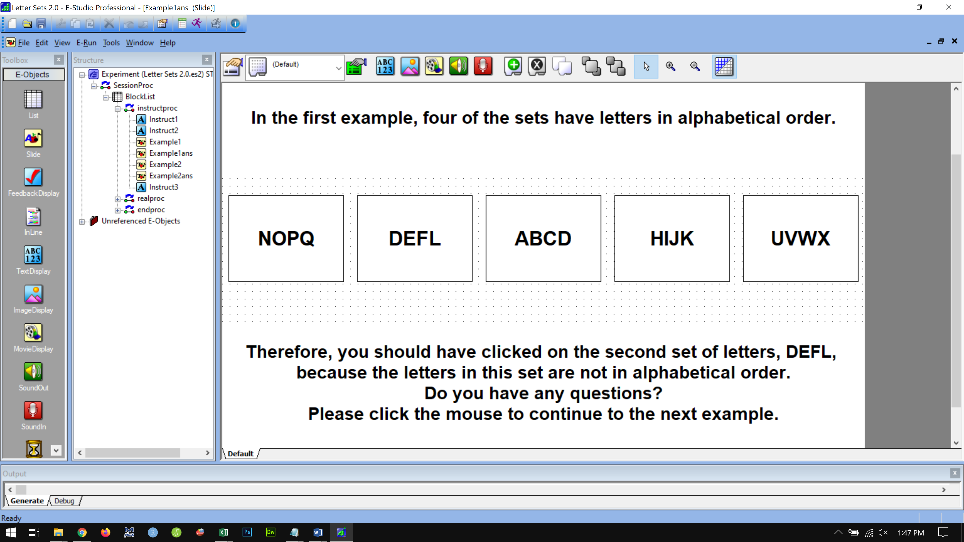

Example2

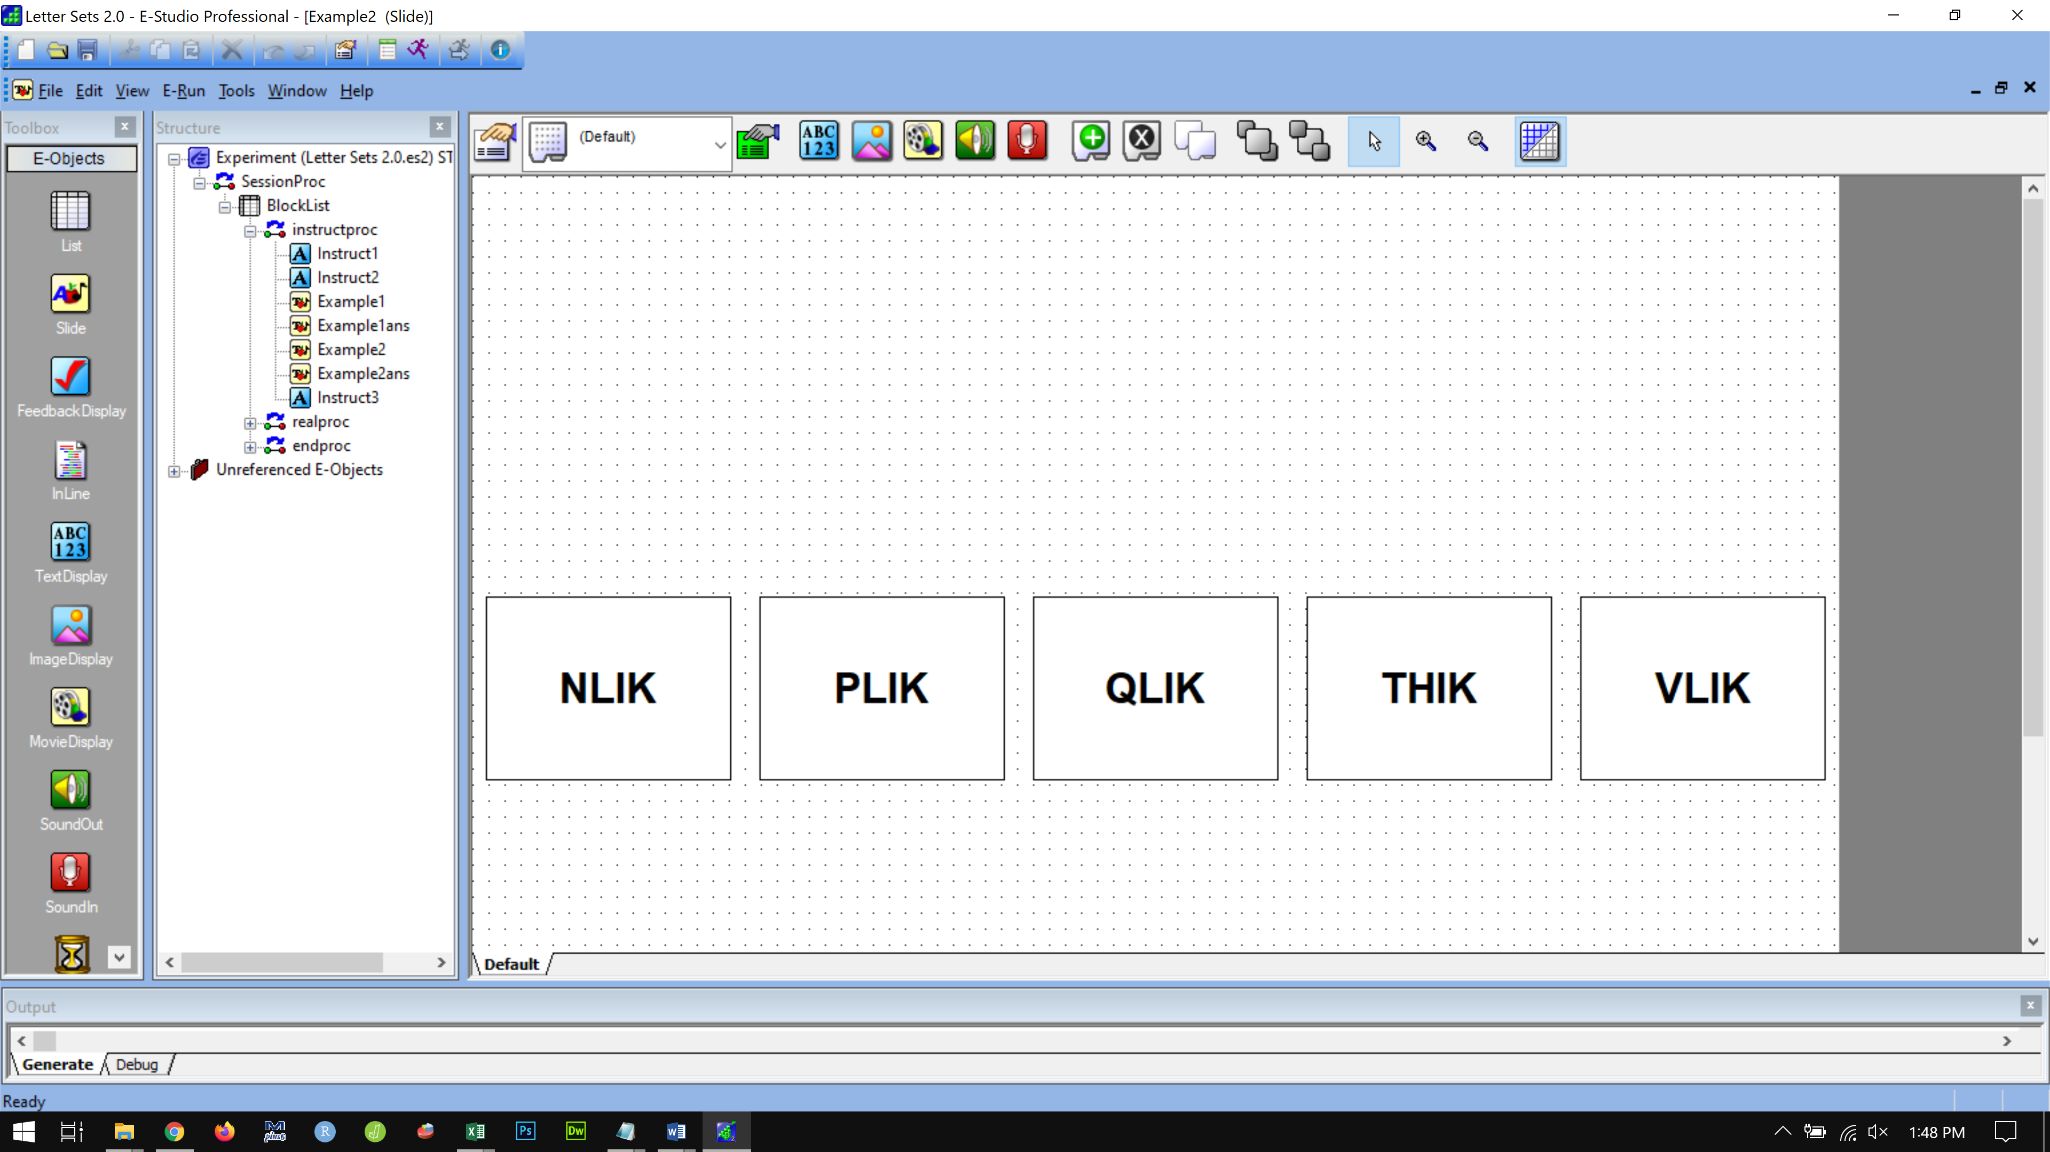

Example2 ans

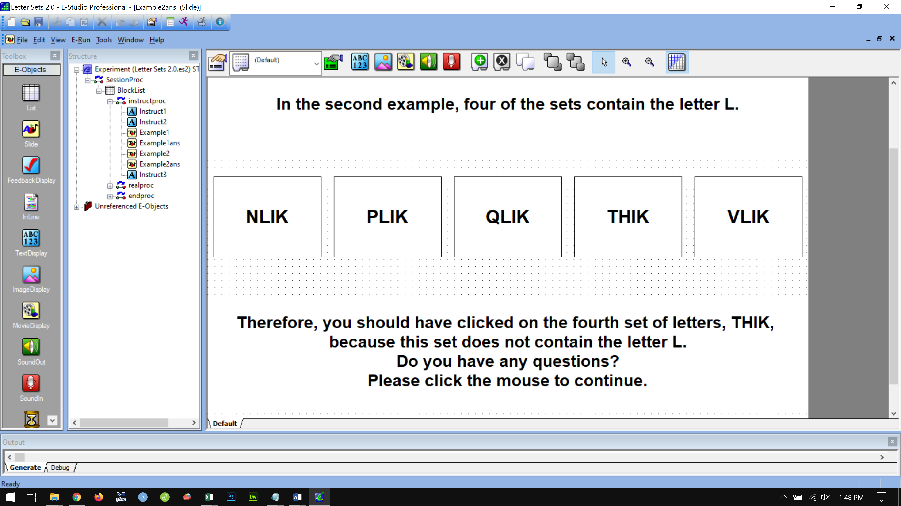

Instruct3

There are 20 problems in the experiment. You have 5 minutes to complete the experiment.

You will find the problems in this set slowly get more difficult.

You may not finish all the problems in the set before the 5 minutes, so do as many as you can. The accuracy of your work matters most. Try your best to select the correct answer before moving on to the next problem.

Do you have any questions?

Press the SPACE bar to begin the real problems.